SQL PRACTICE NOTES
TOPIC: DDL, DML, DCL, TCL COMMANDS
DATABASE: BANK MANAGEMENT SYSTEM
2520030263
N. Madhan

SECTION 1 : DDL (DATA DEFINITION LANGUAGE)
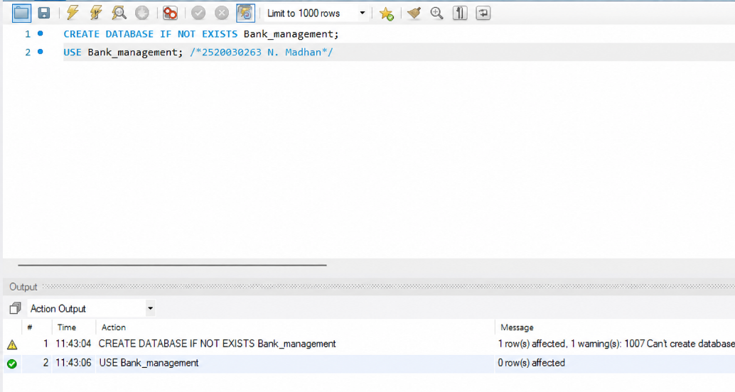
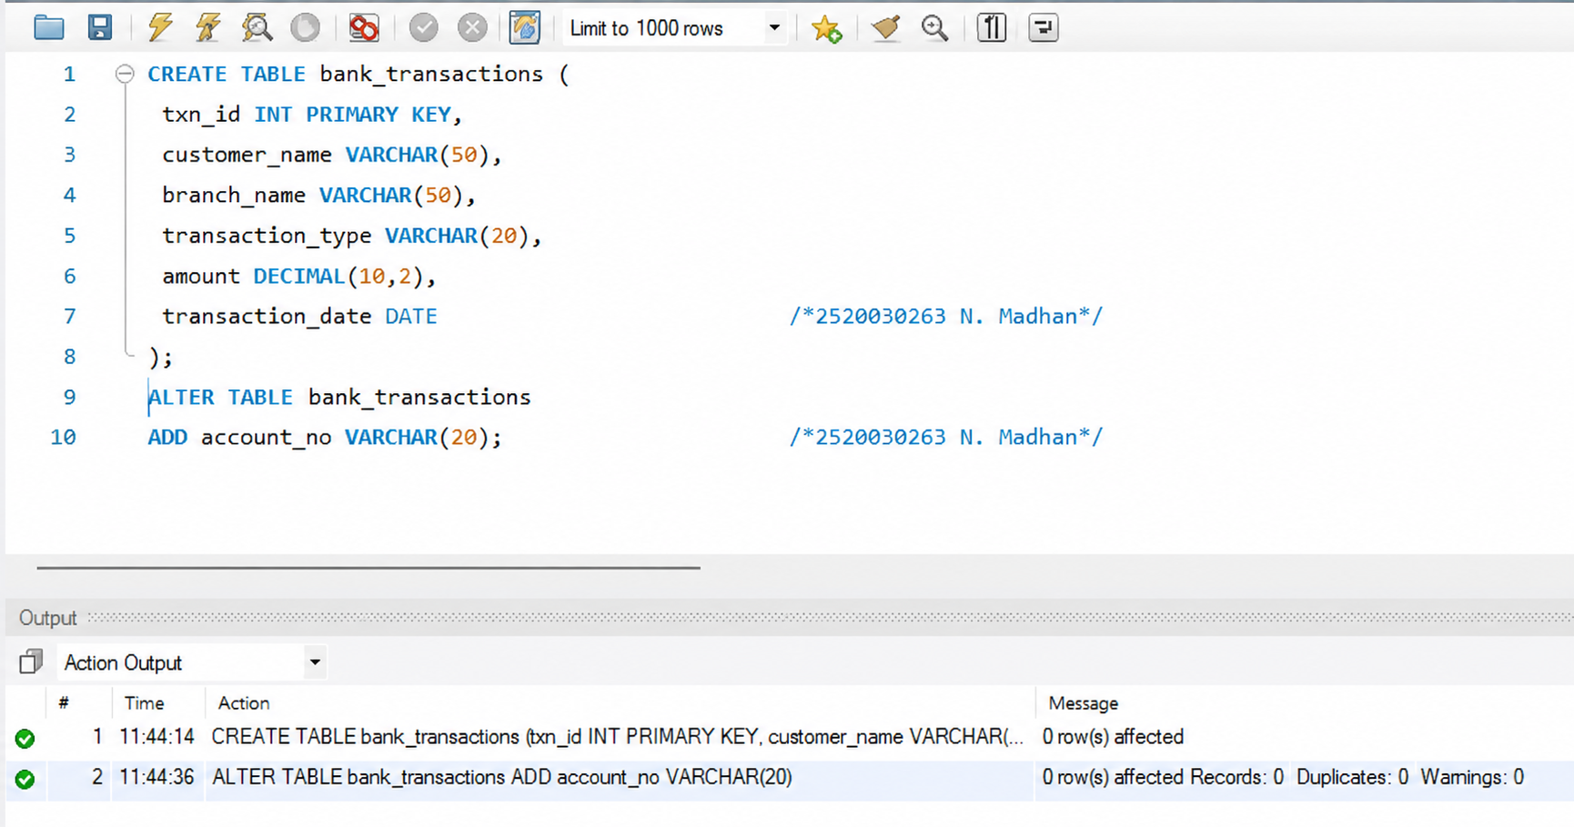
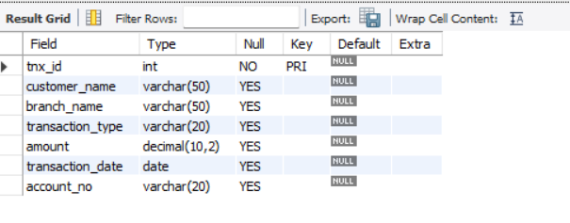
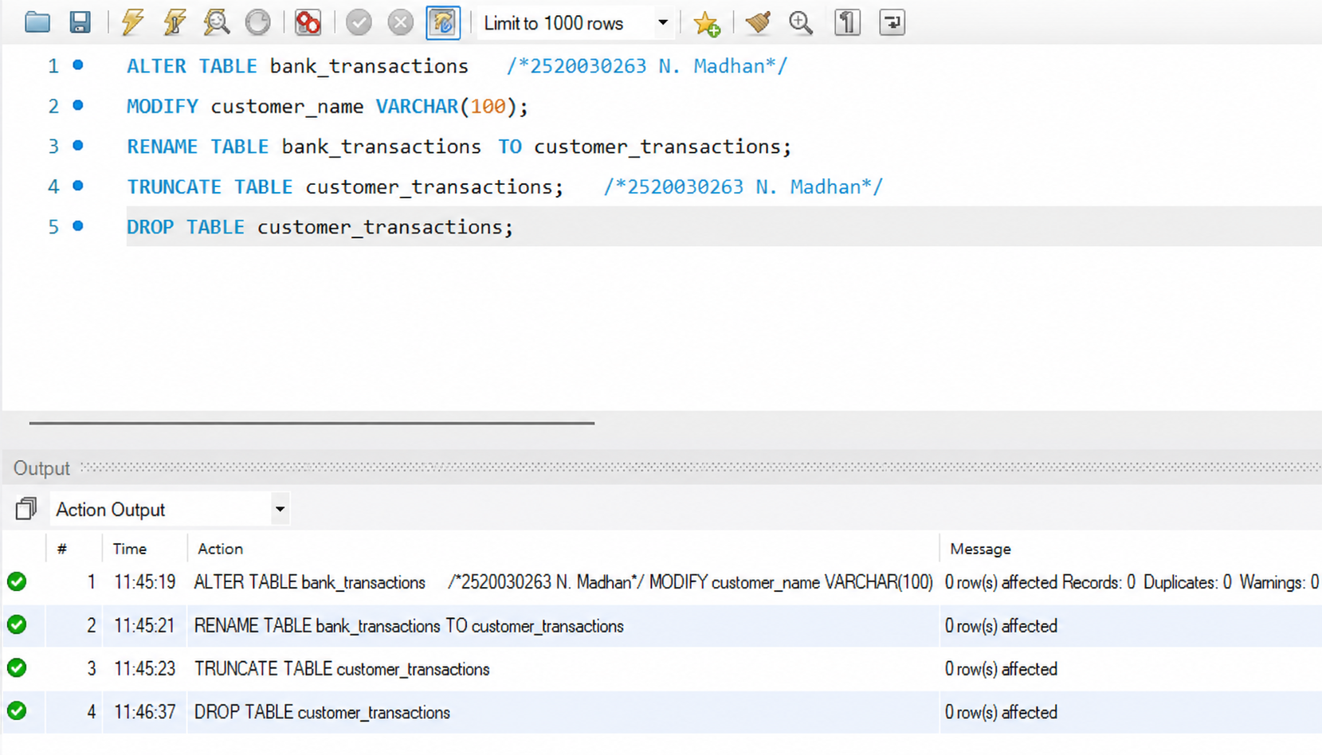

SECTION 2 : DML (DATA MANIPULATION LANGUAGE)
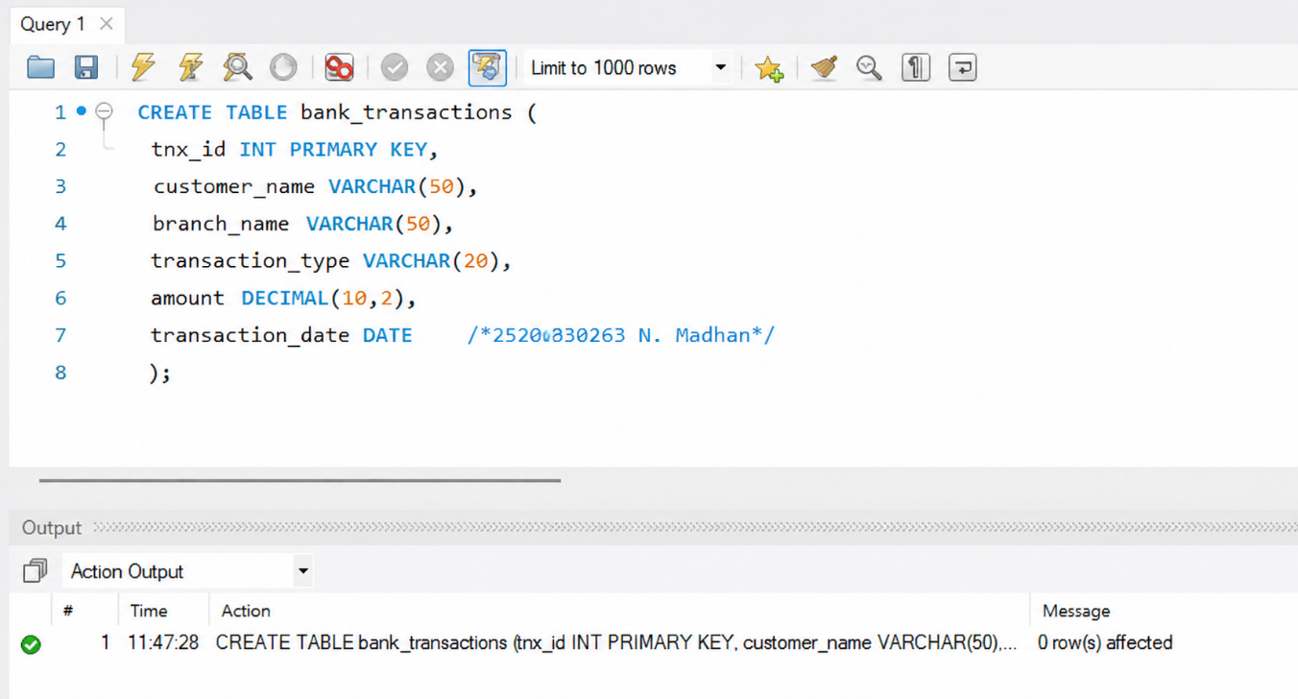
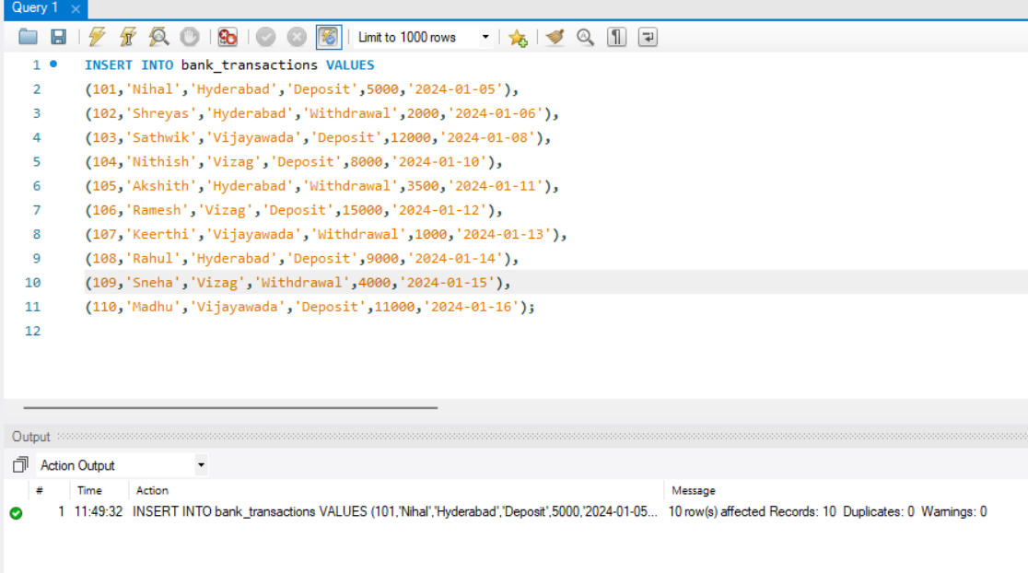
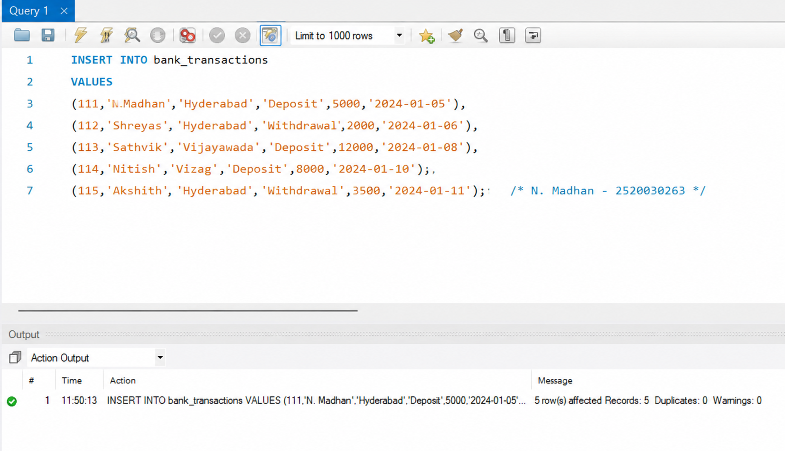

SECTION 3 : DCL (DATA CONTROL LANGUAGE)
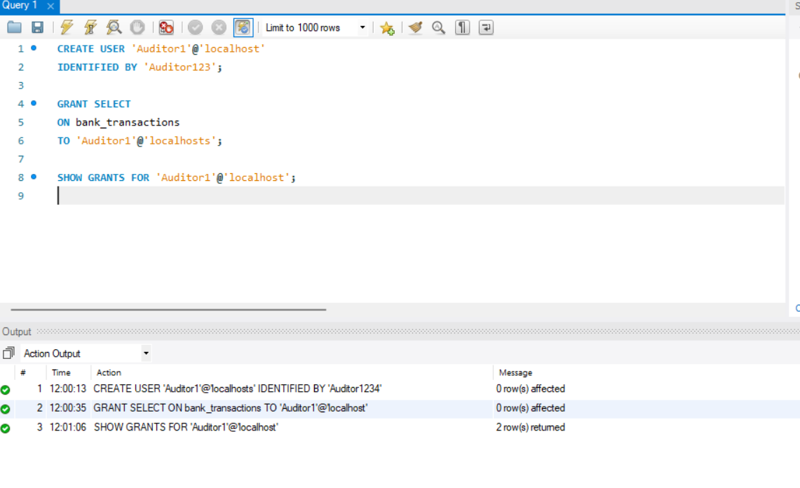
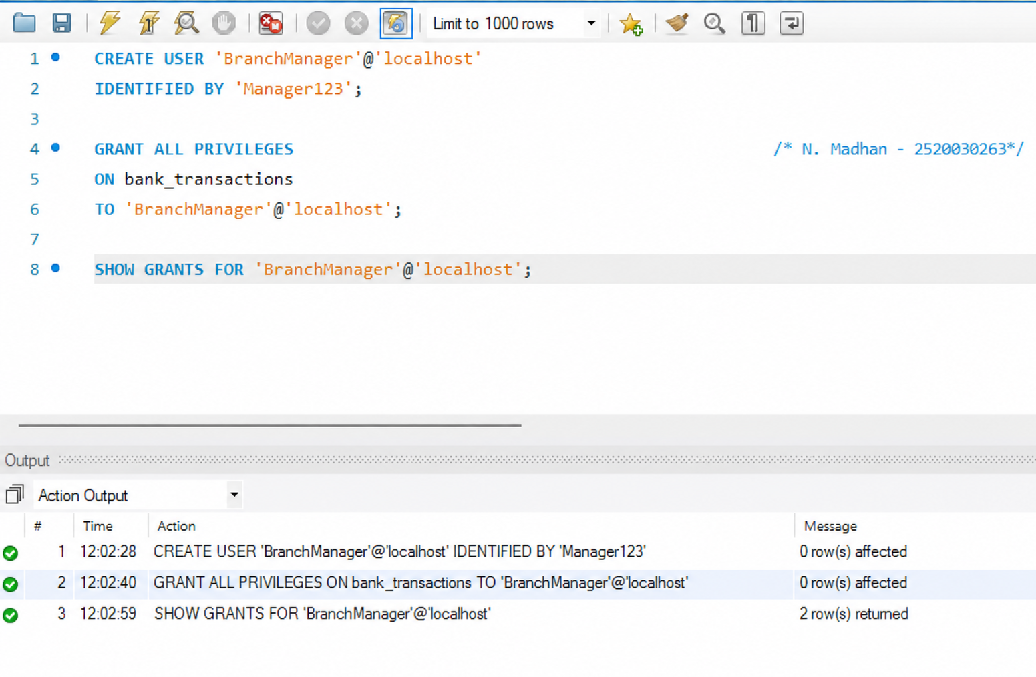

SECTION 4 : TCL (TRANSACTION CONTROL LANGUAGE)

